Kol simcha torah gazette
For parshas acharei mos 5784
Volume 8 Issue 34 (Whole #392) 26 Nisan 5784/ May 4, 2023
Printed L’illuy nishmas Nechama bas R’ Noach, a”h

For a free subscription, please forward your request to keren18@juno.com
Past emails can be found on the website ShabbosStories.com under Brooklyn Torah Gazette
Two Great Books for
Afikomin Presents
By Daniel Keren

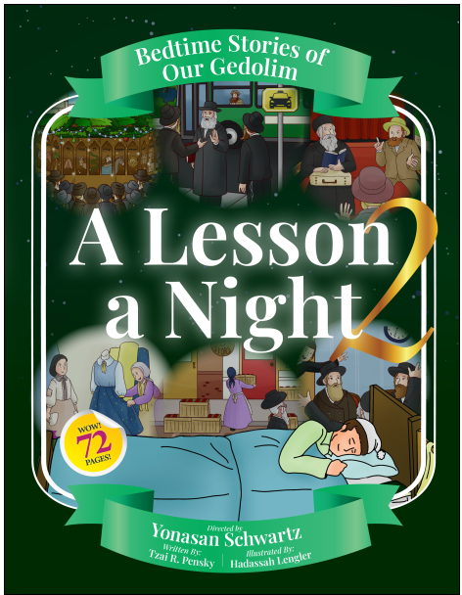

Wishing that all of my readers and Klal Yisroel had a Kosher and Sameach Pesach. The highlight of the Festival of Freedom was the Seder night, with family and friends getting together to recite the Haggadah. The focus of the Seder is to encourage children to ask questions. Many children look forward to the night in order to “steal” the afikomin and negotiate gifts in exchange for returning that important broken matzah.
Many parents might try and persuade their children to surrender the afikomin with an inspiring book. Chazak Distribution has just released two new books for kids of all ages – the second volume of “A Lesson a Night” and “Sparks of Greatness.” Both books were written by Tzai R. Pensky and illustrated in cartoon format by Haddasah Lengler. The books were edited by Yaakov Herskovich and the project was directed by Yonasan Schwartz.
The 72-page “A Lesson a Night 2” contains 11 stories previously published in other Jewish newsppers. Many of these stories are classic that were formulated in a manner that children would appreciate.
How did Rav Yeruchim Levovitz (1873-1936) react when he discovered that he had lost one of his gloves? Or how did the great Chief Rabbi of Yemen (Rav Yihye Yitzhak Halevi) solve the problem of the extra coins in the bag that a Jew had returned to a prominent Muslim resident who accused of not returning all of the coins?
There are also other inspiring stories for children of all ages that recall stories of Reb Dovid of Lelov (“The Most Precious Sukkah”), Rav Aharon of Karlin (“Horse Talk”), Rav Yechezkel Landau (“The Crooked Wagon Driver,”) Reb Meir Shapiro (“The Allowance,” Reb Shlomo Zalman Auerbach (“The Early Delivery), Rav Avraham Genachovsky (“The Grumpy Passenger,”) Rav Aharon Schechter (“A Personal Thanks,”) Reb Zusha of Hanipol (“The Wedding Dress,”) Rav Yitzchak Elchanan Spektor (“Excellent News,”) and the Ridvaz (“The Warmest Winter.”)
At the end of each story is a poignant Lesson Learned that will be appreciated by both parents, teachers and even grandparents.
The second illustrted book of 35 stories of our Gedolim – “Sparks of Greatness,” that will make children enjoy learning about important middos, character traits from some of Klal Yisroel’s most famous Torah leaders and teachers such as the Chazon Ish (“The Sweetness of Torah”), the Klausenberger Rebbe (“A Full Meal in Auschwitz,”) the Kotzker Rebbe (“True Olam Hazeh,”) Rav Chaim Soloveitchik (“Dual Intentions,”) the Alter of Kelm (“The Special Seder,”) the Bobover Rebbe (“The Rebbe’s Daily Snack,”) the Beis Halevi (“Torah Wisdom,”) Rav Akiva Eiger (“The Power of Tefilla,”) Rav Snueur Kotler (“Learning in the Hallway,”) Rav Chaim Yisroel Belsky (“The Skipped Limb,”) and Rav Dovid Feinstein (“Time to Daven.”)
Both “A Lesson a Night – volume 2” and “Sparks of Greatness” take important hashkafa topics and convert them into a format that children can comprehend, that is the result of a lot of serious editorial efforts made by both the writer and illustrtor. These books are now in Jewish bookstores or can be purchased on various online venues..

What Should Have Been the Proper Reaction of the Jews
in Tel-Aviv to the Missile Attacks this Week?

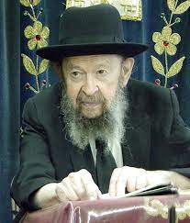

They should have huddled in their rooms in fear of Hashem, no question about it. It was a time to make an accounting. When a scud missile fell on Tel-Aviv, so the mayor of Tel-Aviv should have thought about what he said in defiance of the Orthodox Jews. The Orthodox Jews wanted to make a law that all places of amusement should be closed on Shabbos. So, the mayor of Tel-Aviv said, “Nothing doing! In Tel-Aviv, I’ll see to it that every Friday night all these places, the cafes and the theaters will be open all night long.” So, when the scud fell on Tel-Aviv, he should have said, he should have announced, “I changed my mind.” Because that’s the purpose!
You think that’s the end? I’m telling you, it’s only the beginning. Saddam Hussein is only the first shot in the great battle against the evil that holds sway in Eretz Yisroel. It’s only the first shot! Hashem is not finished at all. Hakadosh Baruch Hu sent a warning. But for people who refuse to listen, He might have to send another one.

Reprinted from the Acharei Mos 5784 email of Toras Avigdor, based on the teachings of Rav Avigdor Miller, zt”l. Adapted from Tape #815 (March 1991).
The Mistake of the Pursuit
For Spiritual Ectasy
From the Teachings of the Lubavitcher Rebbe
Rabbi Menachem Mendel Schneerson, Zt”l
Adapted by Rabbi Jonathan Sacks, Zal


Acharei Mot begins by mentioning the death of Nadab and Abihu, the sons of Aaron. Their death, related in the Sidra of Shemini, is something of a mystery, for on the one hand they seemed to be punished for their faults, while on the other, a Midrashic comment suggests that their merits were extraordinary, excelling even those of Moses and Aaron. Can we reconcile these two analyses of their character?
A Chassidic explanation does so by saying that they died because of a religious ecstasy so intense that their souls literally left their bodies. Was there anything wrong in this? There was. What was mistaken was the pursuit of ecstasy at the price of life in the world. They ran towards the higher realms without thought of returning. And yet the Jew must always return, for his task lies within the world, sanctifying, not forsaking, his earthly situation. The rhythm of withdrawal and return, of experience and action, is fundamental to Judaism.

1. The Death of Nadab and Abihu
Our Sidra begins with the verse: “And the L-rd spoke to Moses, after the death of the two sons of Aaron, when they drew near to the L-rd and they died.” The final words, however present a difficulty. Why does the Torah add “and they died” when it has already said, “after the death of the two sons of Aaron?”
The Midrash, in giving an explanation of their death, cites the following explanations: They entered the Holy of Holies;¹ they did not wear the priestly garments necessary for their service;² they did not have children; and they did not marry. Our second question now arises: What is the source of the Midrashic account? Where, in the Torah, are these four faults alluded to?
Further: How can we suppose that Aaron’s two sons, Nadab and Abihu, were guilty of a sin? The Rabbis say³ that Moses said to Aaron, “Aaron, my brother, I knew that the Sanctuary would be sanctified by those who were beloved and close to G-d. Now I see that they—Nadab and Abihu—are greater than both of us.” If this was so, how could they have sinned?

2. A Fatal Ecstasy
There is a Chassidic explanation⁴ that Aaron’s two sons did not “sin” literally. Their “sin” was to allow their desire to cleave to G-d to mount to such an intensity that they died. Their bodies could no longer contain their souls. Thus, the Torah says “when they drew near to the L-rd (with such passion that) they died.” And this was counted as a sin! For although a Jew must divest himself of material concerns,⁵ at the moment when he stands poised at the ultimate ecstasy of the soul, he must turn again to the work that the soul must do within a physical existence.
It is written in the Pirkei Avot,⁶ “Against your will you live.” Set against the desire of the soul to rise beyond the world, is its task of creating a dwelling-place for G-d within the world.⁷ Nadab and Abihu achieved the ecstasy but not the return. This was their sin and the reason for their death. They “drew near to the L-rd and they died.” They let their spiritual passion override their this-worldly task. They went beyond the world and beyond life itself.
This act lies at the heart of each of the four faults which the Midrash ascribes to them.
They “entered the Holy of Holies,” the innermost reaches of the spirit, without thinking of their return to the outer world.
They “did not wear the (priestly) garments.” Their concern was to divest themselves of the world and to become purely spiritual. They forsook the necessary “garments” in which the word of G-d is clothed,⁸ the Mitzvot, the physical actions that sanctify a physical environment.
They “had no children” and “did not marry.” That is, they did not fulfill G-d’s command to “be fruitful and multiply” and to bring new souls into the world. They did the opposite. They withdrew their own souls from the world.
All their faults stemmed from a single misconception, that the Jew draws close to G-d by withdrawal instead of involvement. In fact, both are necessary. And that is why, at the point of the year when we are most powerfully taken out of the world—Yom Kippur—we begin the reading of the Torah from these verses, as a reminder of our ultimate task.

3. Entrance and Exit
Rashi explains that the command, “that he (Aaron) come not at all times into the holy place… (but) with this shall Aaron come into the holy place,” comes immediately after the statement of the death of his sons, to warn that his (and our) service should not be like that of Nadab and Abihu.
A question arises here. Can we really demand of a person at the point of ecstasy, that he return to his mundane role? If his experience is genuine, if he has reached the love of G-d “with all your might” and has broken through all barriers of separation between man and G-d, can he hold himself back at the very point of union, and reimmerse himself in all the constraints of the human situation? Is there not an emotional incompatibility between the absolute abandonment of a person to G-d and a constant vigilance not to go too far?
The answer lies in how a person begins his spiritual journey. If he sets out with the intention of satisfying his own desires, however exalted they are, he will not wish to turn back from his private ecstasy to the needs of the world. But if he sets out in obedience to G-d’s command, knowing that though “You shall love the L-rd your G-d… with all your might,” nonetheless “He created (the world) not to be empty, he formed it to be inhabited,”⁹ then within his ecstatic approach to G-d, the desire ultimately to return and sanctify the world will always be implicit.
There is a famous story in the Talmud.¹⁰ Four men entered the “Grove” (the mystical secrets of the Torah): Ben Azzai, Ben Zoma, Acher and Rabbi Akiva. Ben Azzai looked and died. Ben Zoma looked and was stricken (with madness). Acher mutilated the shoots (i.e., became an apostate). Rabbi Akiva “entered in peace and came out in peace.”
On the face of it, the important difference between Rabbi Akiva and the other three was in how he came out of the “Grove.” Why does the Talmud emphasize that he “entered in peace?”
But the truth is that how each of the four entered, determined how they emerged. Ben Azzai entered seeking ecstasy, not return; therefore he “looked and died.” (It is interesting to note that his Divine service was generally characterized by aspects of withdrawal.)¹¹
But Rabbi Akiva entered “in peace,” in obedience to the Divine will and seeking to unite the higher and lower worlds. That is why he came out in peace. His intention of returning was implicit at the outset of his path to religious ecstasy.
This, too, was how Aaron was to enter the Holy of Holies, in fear, obedience and self-abnegation. And in this way he was able to “make atonement for himself and for his house”¹² and to say a prayer for the sustenance of Israel,¹³ each of them acts of concern for the world.

4. Experience Into Action
All the Torah’s narratives have a teaching which is applicable to every Jew,¹⁴ not simply to the outstanding few. What, then, is the universal significance of the story of Nadab and Abihu? Surely not everyone can reach a level of ecstasy where one’s life is in danger. A few need the warning; but what of the many?
But every Jew is sometimes awakened to an intense religious experience, especially on Shabbat and the Festivals, more particularly during the Ten Days of Repentance,¹⁵ and above all on Yom Kippur. He is for a while taken out of his daily routine, his normal anxieties, and inwardly rises beyond his usual mental confines.
It is at these times that he must remember that whatever he experiences when he enters this holy domain must be carried with him when he returns to his everyday world. He must not seek ecstasy for its own sake, but for the sake of the subsequent return. A religious experience must not be left as a memory; it must remain active in animating the whole of his life. Like Rabbi Akiva, he must enter and come out “in peace,” that is, bringing G-d and the world closer together in harmony.

5. The Blessing of G-d
This connection between the manner of entering and of leaving the realm of holiness, applies not only to the service of the Jew, but also to the material world itself. For all the Jew’s needs, material as well as spiritual, come to him directly from G-d: “If you walk in My statutes and keep My commandments and do them, then I will give you rain in due season, and the land shall yield her produce….”¹⁶ Only through his bond with G-d does the Jew receive his material needs. He who says “It will be well with me for I will walk in the stubbornness of my heart” is always in the last analysis proved mistaken.¹⁷
And this is intimated in our Sidra, describing the procedure of the High Priest’s service. It was only after he had entered the Holy of Holies that he was able to pray for and secure the sustenance of the people.
So it is that the public world that the Jew inhabits, and the private world of his religious experience, are intrinsically related. For if he draws his experience into the world, the world is thereby sanctified by man and blessed by G-d.
(Source: Likkutei Sichot, Vol. III pp. 987-993)

Reprinted from “Torah Studies (Kehot Publications)” adapted by Rabbi Jonathan Sacks, the late Chief Rabbi Emeritus of Great Britain and the Commonwealth.

Rabbi Berel Wein on
Parshat Achrei Mos 5784

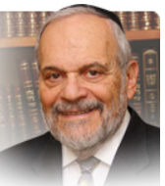

The Torah has already described the tragedy of the family of Aaron, when his sons Nadav and Avihu died while performing incense burning on the day of the final dedication of the Mishkan/Tabernacle. So, why does the Torah return to the subject and mention it again in this week’s Torah reading? The commentators over the ages, from the time of the Talmud onwards, have derived many explanations, laws and moral ideas from the repetition of this incident here in this parsha.

Since the Torah is limitless, eternal and speaks to all generations, I take the liberty of suggesting another idea to help us understand the depths of the Torah’s sensitivity to the human psyche and condition.

In a subtle but important way the Torah emphasizes that from now on everything that Aaron and his sons will do in the service of G-d and Israel, inside the holy Mishkan/Tabernacle or outside of it, will always be influenced by the tragedy they witnessed and experienced on the day their sons and brothers died. Moshe’s comment that Nadav and Avihu were holy and sanctified people, close to G-d, so to speak, only amplifies the tragedy and makes it more difficult to comprehend and rationalize.

For the rest of their lives, Aaron, his surviving family and the entire Jewish nation will be haunted by this tragic event. It will hover over every occurrence that will befall them, personally or nationally, for all time. Everything will now be encapsulated in the time frame of “after the death of the two sons of Aaron.” And this idea is implicit in the message of the Torah to us this week.

The Holocaust….the inexplicable iniquity of this tragedy haunts the Jewish people today, even decades after the fact. It seems that every accomplishment and shortcoming in Jewish life generally, and regarding the State of Israel particularly, is Holocaust driven. Everything is seen as being holy vengeance or justified retribution, as “remember and do not forget,” or “never again!”

There is no event that takes place in Jewish life today that does not have Holocaust overtones. We are always “achrei mot” - after the tragedy that brooks no explanation and constantly challenges our faith on one hand and our rationality on the other. It is as though the formal commemorations of the Holocaust are not that special and unique, hard as we try to make them so, because every day and every occurrence now is still just another form of that memorial.

Naturally, the formal commemoration of the Holocaust invokes again the emotional connection to this enormous national tragedy. That is why such a national day of mourning is justified and necessary. And this only enhances our realization that we are all living in the time of “achrei mot.” And this explains a great deal of the mood and behavior of the Jewish people in our time.

And now, since October 7th, and with the war that we are engaged in now, “Achei mot” reflects the attitude and behavior of our people.

Shabbat shalom

Reprinted from the current website of rabbiwein.com

An Open Letter to Jewish College Students
by Ari Joseph Khaytser

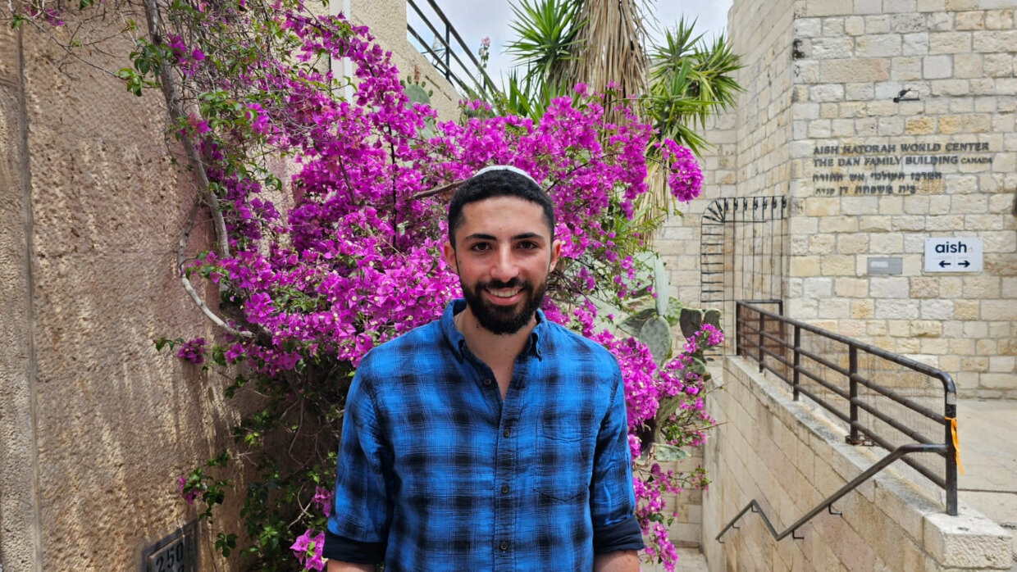

I was a Jewish activist on campus who stood up to anti-Israel protesters. Here are a few essential points Jewish students should keep in mind.
In the past two weeks, university campuses all over the U.S. have seen the rise of anti-Israel protests and “encampments” by students. Unfortunately, many of these protests have involved antisemitic chants, flags, outspoken support of Hamas, Hezbollah and other radical terrorist groups, and sometimes even violence against Jewish students.
I graduated from New York University last semester in the winter of 2024. I was involved with several Jewish and pro-Israel organizations on campus and saw the outbreak of these anti-Israel protests when the Israel-Hamas war started after October 7th. I was appalled by my school’s lack of response to the antisemitism at these protests and tried to stand up to it on my own.
Protestors spat on me, called me Jewish slurs and other names, and attempted to assault me. I was forced to defend myself against a protester who tried to steal my Israeli flag. They falsely accused me of intimidation and harassment, and as a result I had to attend student conduct meetings and faced potential sanctions from the school, until video evidence clearly proved I had done nothing wrong.

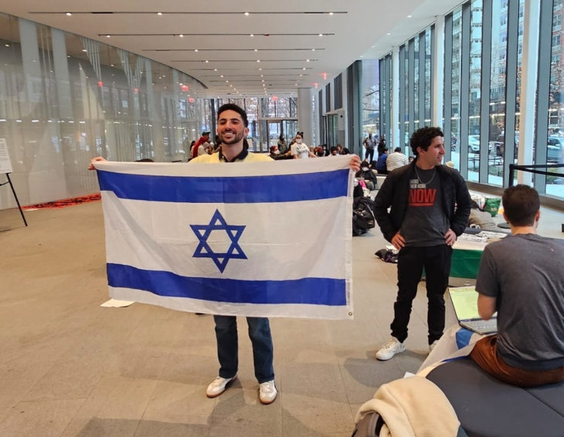A calm moment at NYU

I am very fortunate to now be in Israel and away from all of that. But reading the news about the current situation on university campuses in the U.S. makes me worried that many Jewish students are currently experiencing what I went through or worse. Here are a few essential points Jewish students should keep in mind as the college semester wraps up:

Find a Community
It’s easy to feel like you are alone and unwelcome when facing such an environment on campus, but you are not. Finding and getting involved with Jewish and pro-Israel communities on campus such as SSI (Students Supporting Israel), Olami, Meor, Hillel, etc. will give you social and emotional support during difficult times. These programs have chapters in schools all over the country. They run events discussing the current political situation and providing opportunities to help support Israel through fundraisers, volunteering, outreach, and other means. If you are interested in counter-protesting the antisemitism on your campus, doing so in an organized group through these communities is a much safer and more productive way to do so.

Do Not Concede the Narrative
With the crisis at Columbia that has taken over the news in recent weeks, some Jewish leaders have come out urging all Jewish students to stay off the campus. I disagree. I believe cowering to extremists and conceding control of the narrative is how we have gotten to this point. Continuing to do so will only embolden them further.
It may be hard to believe, but the majority of students do not oppose the existence of Israel. The perception exists because the extreme minority is the most vocal. We need to have those of us on the side of humanity pushing back against them to prevent the window from shifting further. Of course, all Jewish students should protect their own safety and not put themselves in situations where they can be harmed. At the same time, I would argue for all Jewish students to do whatever they can to speak out publicly in support of Israel. This can be through social media, participating in volunteering and fundraisers, or attending organized counter-protests.

Fight Darkness with Light
In my experiences participating in counter-protests, I’ve seen Jewish students be verbally abused and taunted by their classmates and outside agitators. Seeing this, it’s easy to let anger control you and pull you into shouting matches and name-calling, or even situations that can escalate into violence. These types of encounters only serve to help the antisemites who would love nothing more than to shout insults without having to ponder their own indefensible ideology.
Instead, we should fight darkness with light. One of my favorite moments was when we played songs of peace and unity over the shouts from the anti-Israel crowd. You will never change the mind of those extreme enough to attend protests with chants calling for Israel’s complete destruction, but those watching from a third-person perspective can see the difference between those guided by humanity and those by hate.

Protect Yourself and Limit Your Consumption of the News
During the start of the Israel-Hamas war, after seeing the rise of anti-Israel protests at my school, I found myself constantly reading the news about it and engaging with antisemitic activists on social media and in person at my campus. While it may be disheartening to see antisemitism spreading on your campus, it’s important to not let this deteriorate your mental and emotional well-being. This is not to say you shouldn’t be informed on the matters happening at your campus, as resigning in the fight for student life is not an option. However, there are often more productive ways to stand up to antisemitism with less exposure to it which can leave you feeling overwhelmed or powerless. A lot of Jews disconnect from the craziness of the external world every Shabbat and let God run the world for a day. I suggest keeping this principle in mind next time you feel the need to read about the latest developments.

Compile Evidence of Any Antisemitism
Keep a record of any antisemitic activity on your campus. Take videos when you see an incident and try to identify anyone in the videos who is participating in the activity. For university administrations to take allegations of antisemitism on their campuses seriously, we need a compilation of evidence to show a repeated pattern of student actions targeting Jewish students. Report any incidents to the anti-bias or student conduct lines at your school. If the event crosses into any potential criminal activity like battery, theft, or harassment, report the incident to law enforcement as well.
It may feel useless, but administrations do respond to pressure. Working to document and report antisemitic behavior with a pro-Israel group at my school, we were able to create cases against dozens of students who faced sanctions, including multiple who were suspended from the university.

Reprinted from the current website of aish.com.

